IT Help Desk

Multinet Pakistan Private Limited.

Technical Design Document

Version 1.00

**Table Contents**

|  |  |  |
| --- | --- | --- |
| **Reference No** | **Description** | **Page No** |
| *1.0* | ***Purpose of this document*** | *3* |
| *1.1* | ***Overview*** | *3* |
| *1.2* | ***Ticketing System Functionality*** | *3* |
| *1.3* | ***Application Functionality*** | *3* |
| *1.4* | ***User Complaint Registration Screen*** | *4* |
| *1.5* | ***User Complaint View*** | *4* |
| *1.6* | **User can view complaint Status** | *5* |
| *1.7* | **Application Owner View Complaints** | *5* |
| *1.8* | **Application Owner can view Status** | *5* |
| *1.9* | **Administrator can view All Complaints** | *6* |
| *2.0* | **Administrator can update status** | *6* |

**1.0 Purpose of this document**

This document is a generic Technical Design Document. It provides Application functionality and configuration material which is intended to assist the relevant management or technical staff and end users. It is also useful background reading for anyone involved in developing or using the IT Help Desk (IHD)

**1.1 Overview**

This document shows the functionality which is developed by programmer and configuration of the IT Help Desk. It attempts to set standards and create a consistent approach to the design and development of systems across the ITS.

**1.2 Ticketing System Functionality**

* User can create complaints and also attach screen shot
* User can view his own complaints
* User can send Email to Support Engineer

**1.3 Application Functionality**

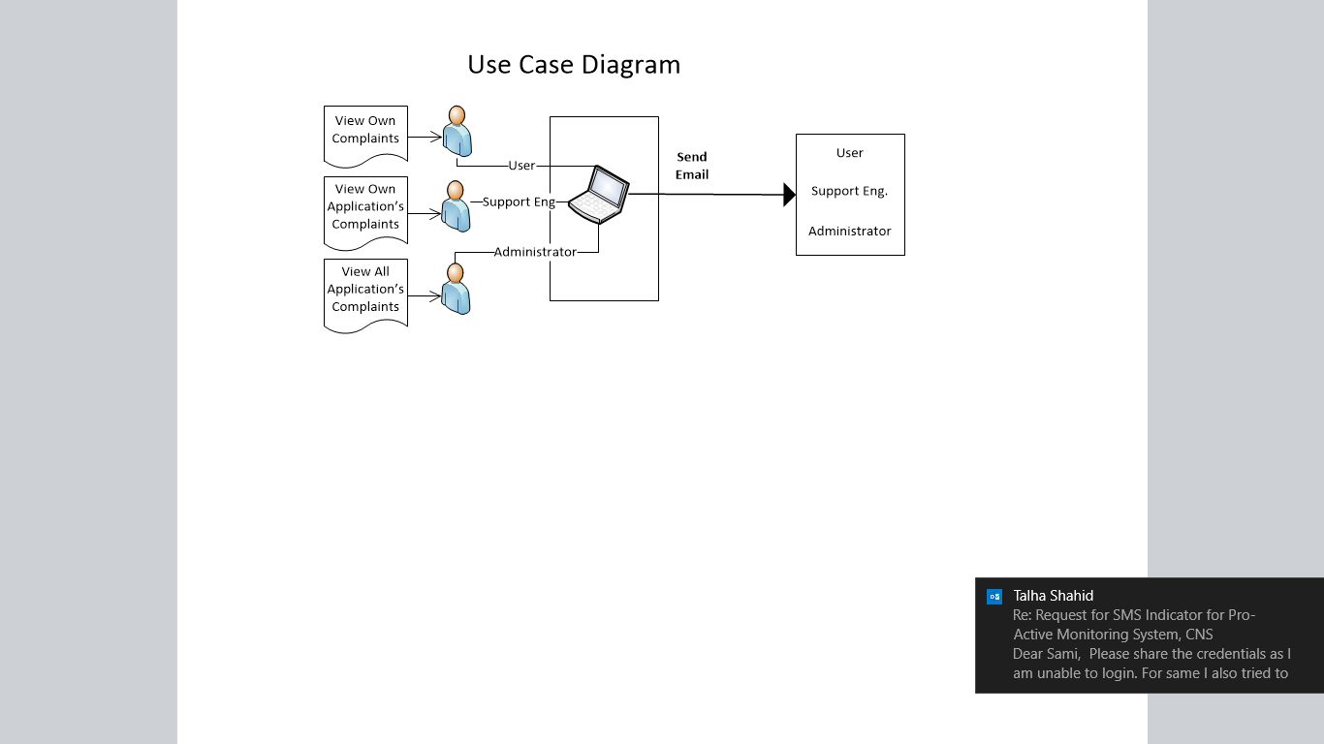

***1.4 Dashboard View***

* From Dashboard View you can view all types of complaint count

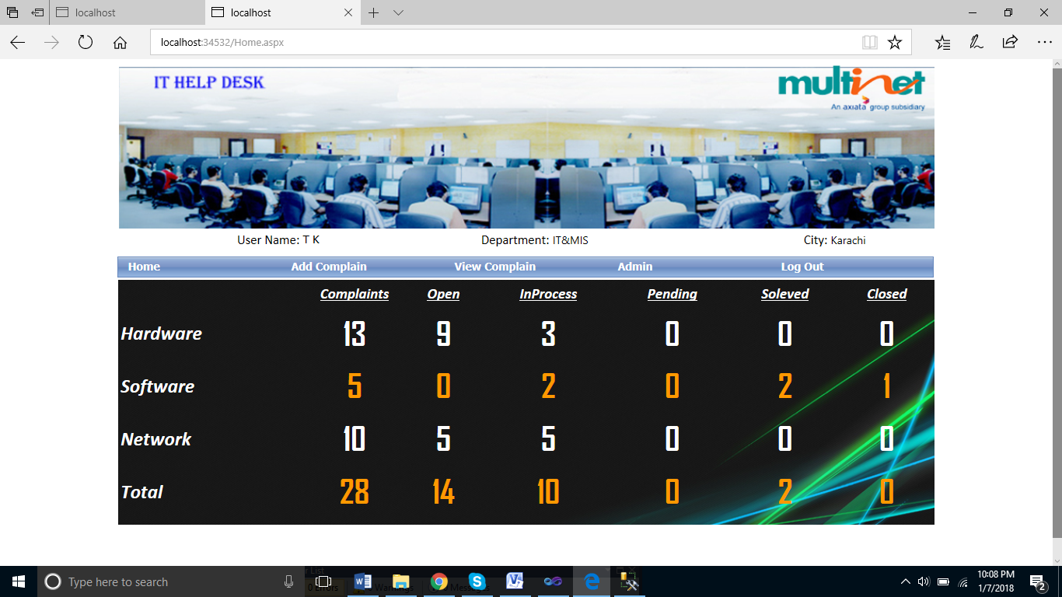

***1.4 User Complaint Registration Screen***

* User can register complaint from the following screen with attached screen shot

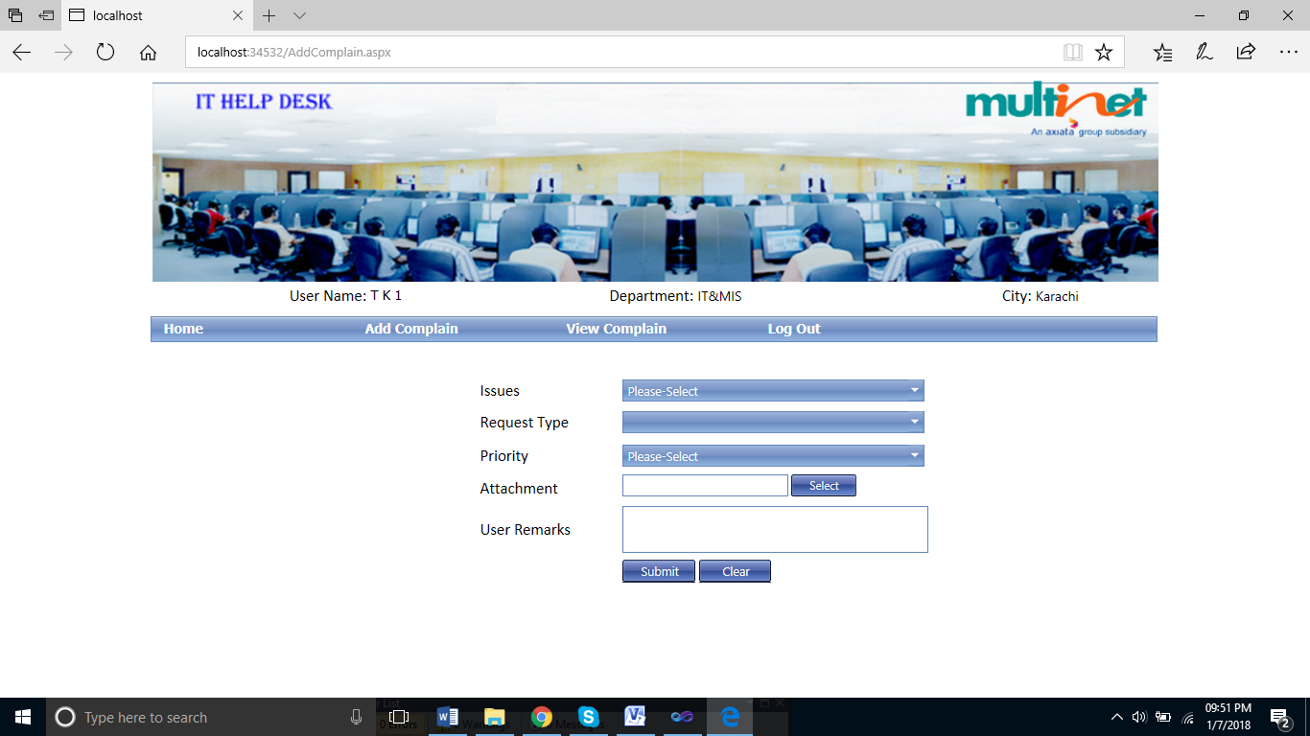

***1.5 After Adding Complaint***

* Complaint Status

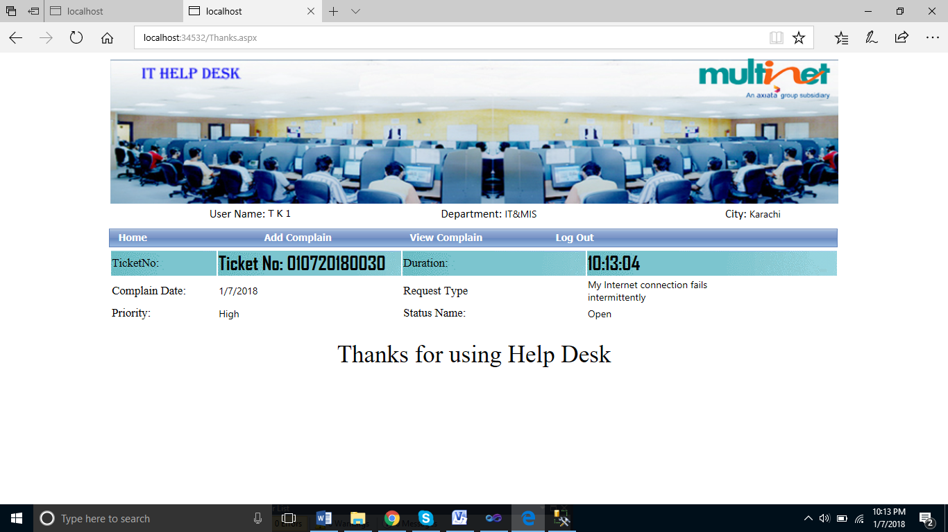

***1.5 User Complaint View***

* User can view his own complaints, screen shot given bellow

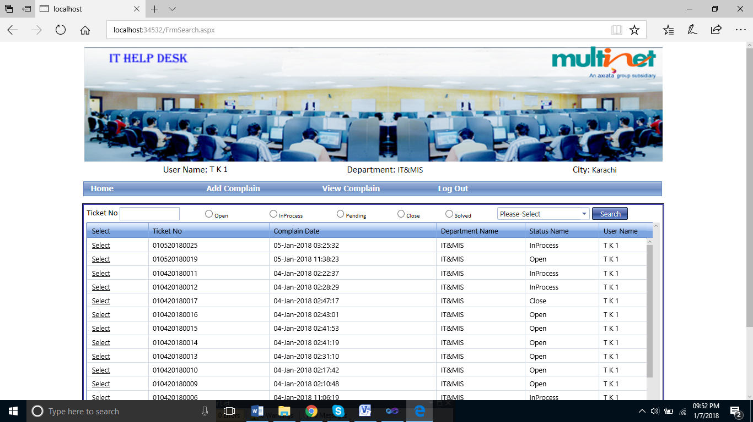

**1.6 User can view complaint Status**

* User can re-open the complaint and update the remarks

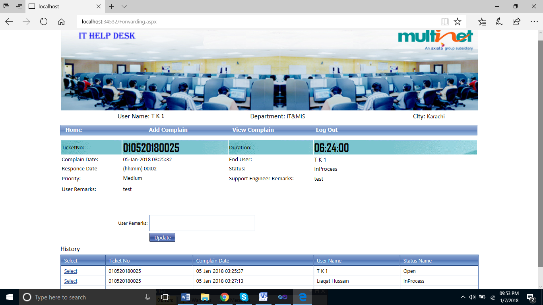

**1.7 Application Support Engineer View Complaints**

* Application Owner can view his own Application complaint at the following screen

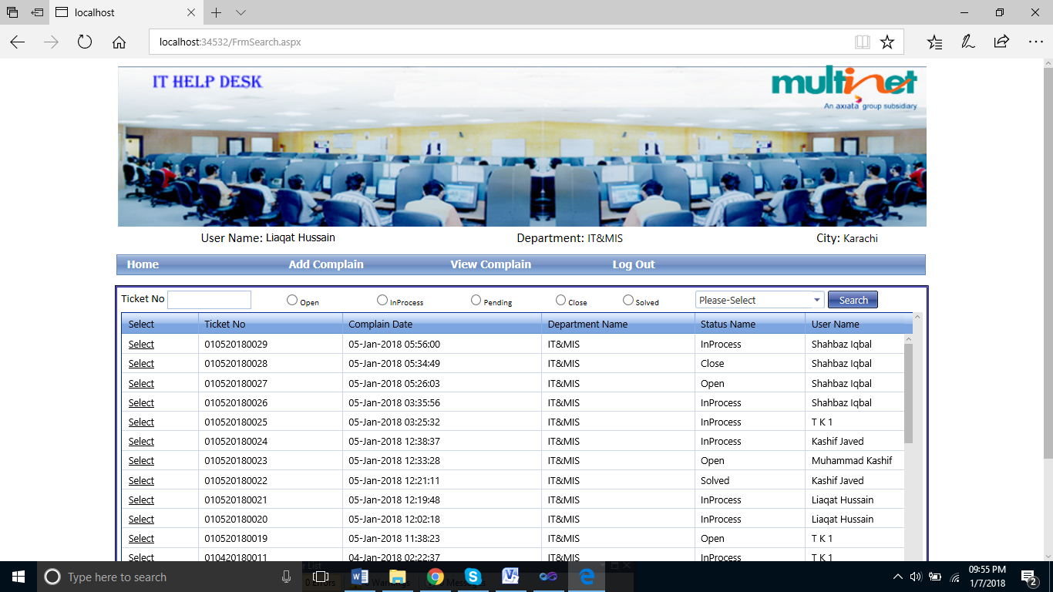

**1.8 Application Owner can view Status**

* Application Owner can update the complaint Status, Resolution time and attachment

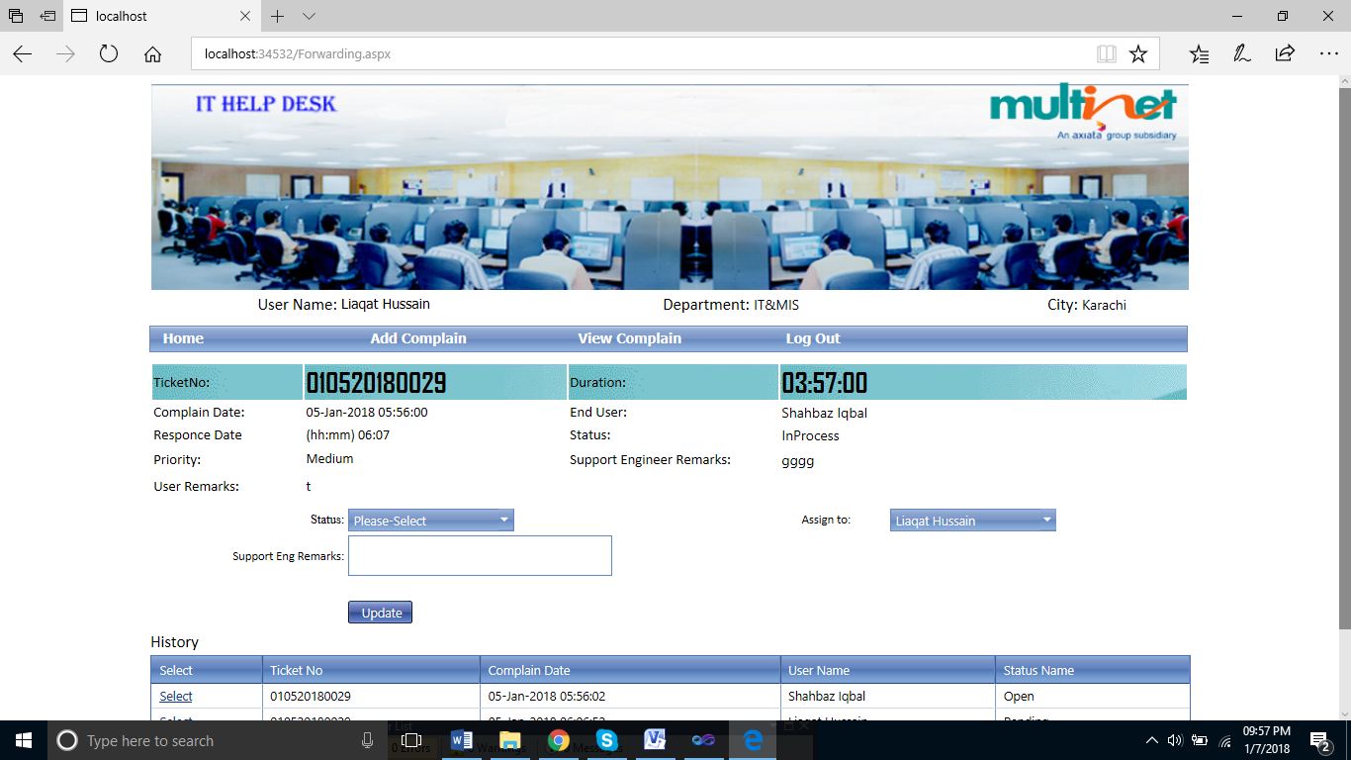

**1.9 Administrator can view All Complaints**

* Administrator can view all complaints

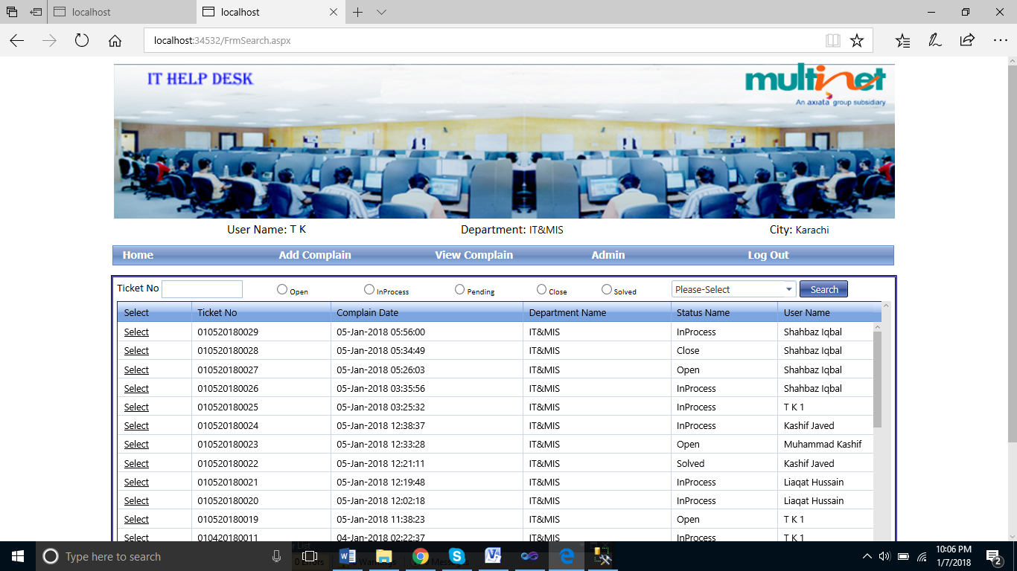

**2.0 Administrator can update status**

* Administrator can update the status, resolution Time, attachment and forward the email to any one developer and vendor

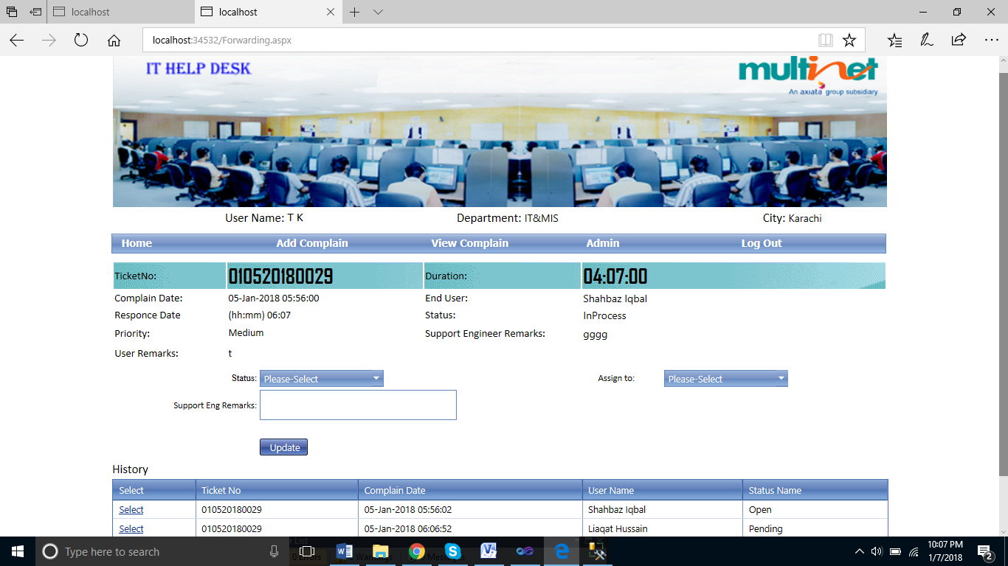

**User Add Complaint and Send Email to Support Engineer**

* User to Support Engineer Email Format
* **Email Flow: User**
* 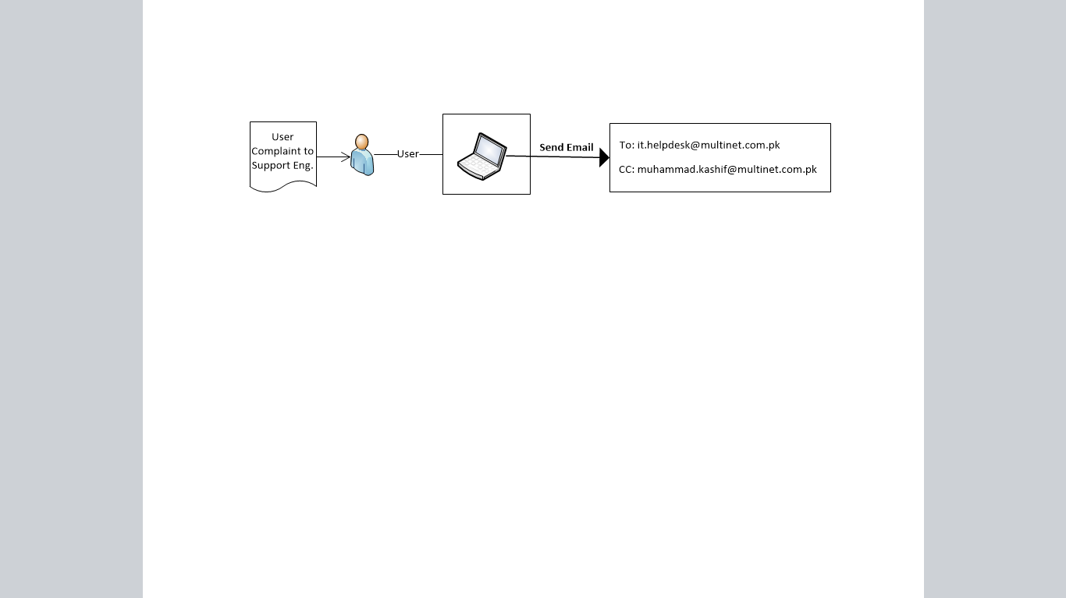

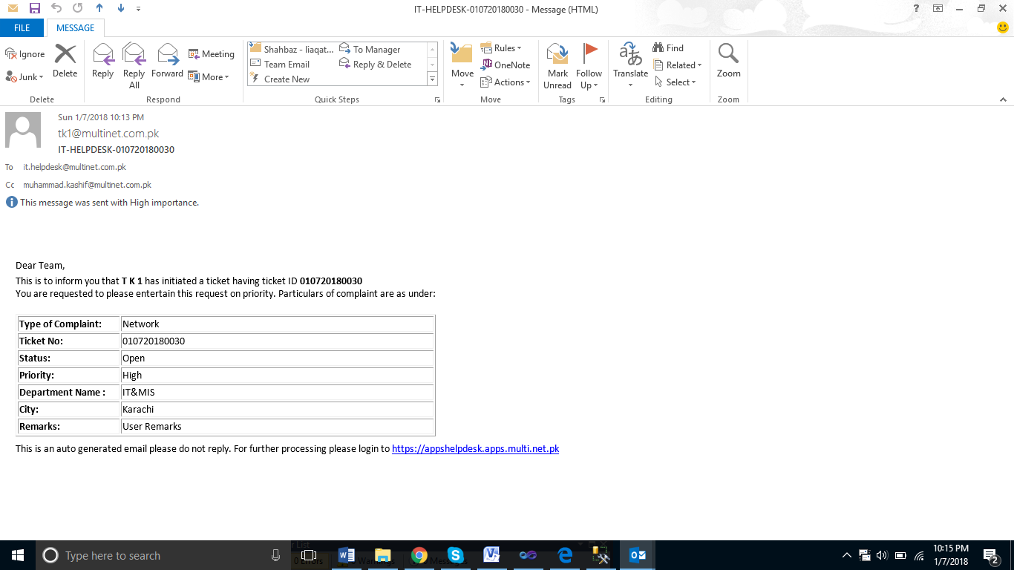

**First Response from Support Engineer to End User**

* Support Engineer First Response
* Email Flow: **In-Process**

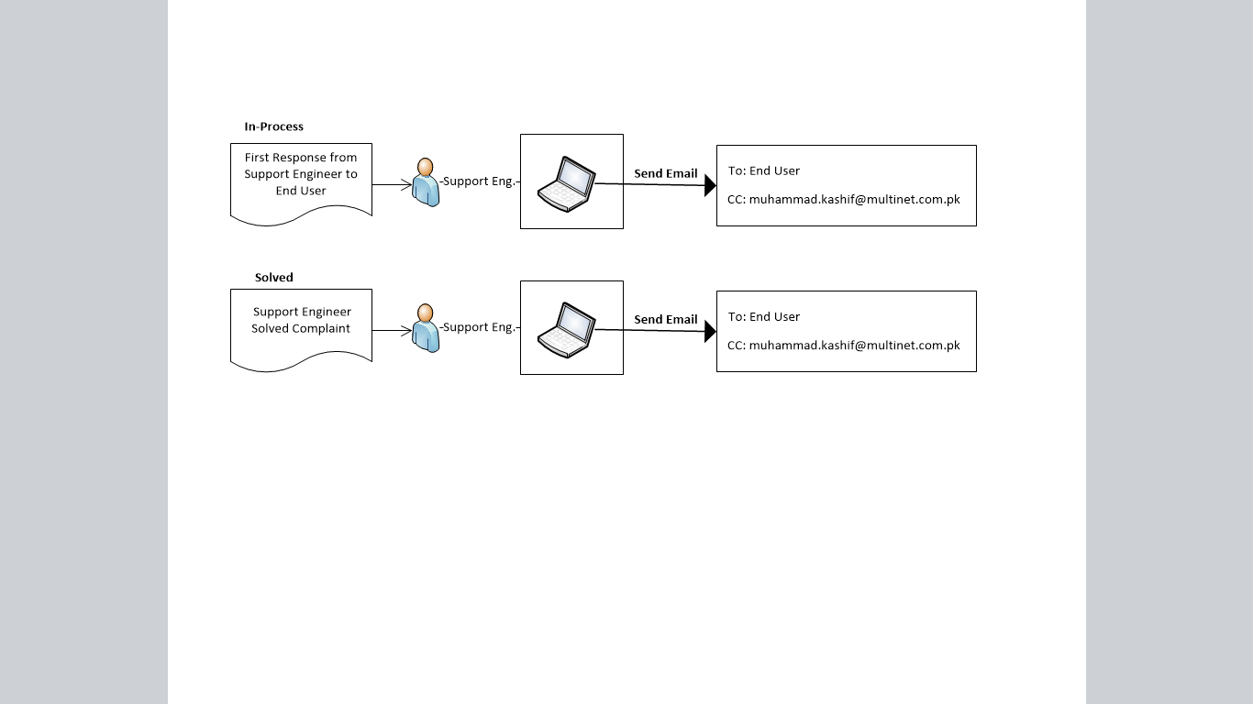

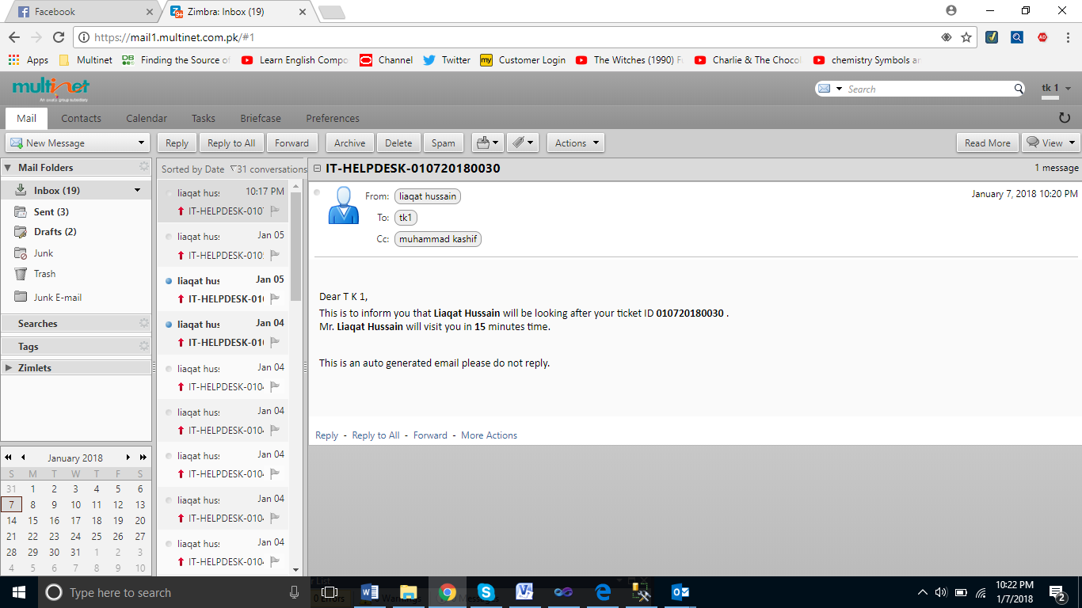

**Support Engineer Resolved Issue and Send Email to End User**

* Support Engineer to End User
* **Email Flow: Solved**



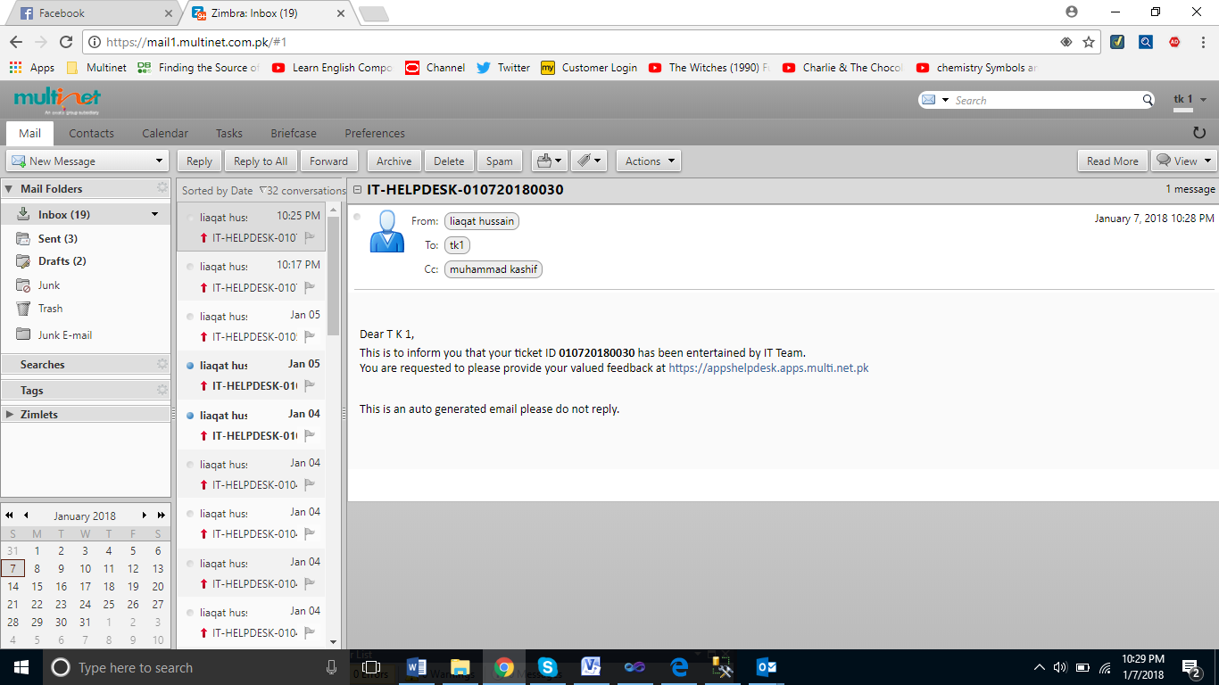

**Support Engineer Send Email in Case of Pending Complaint**

* Pending Complaint

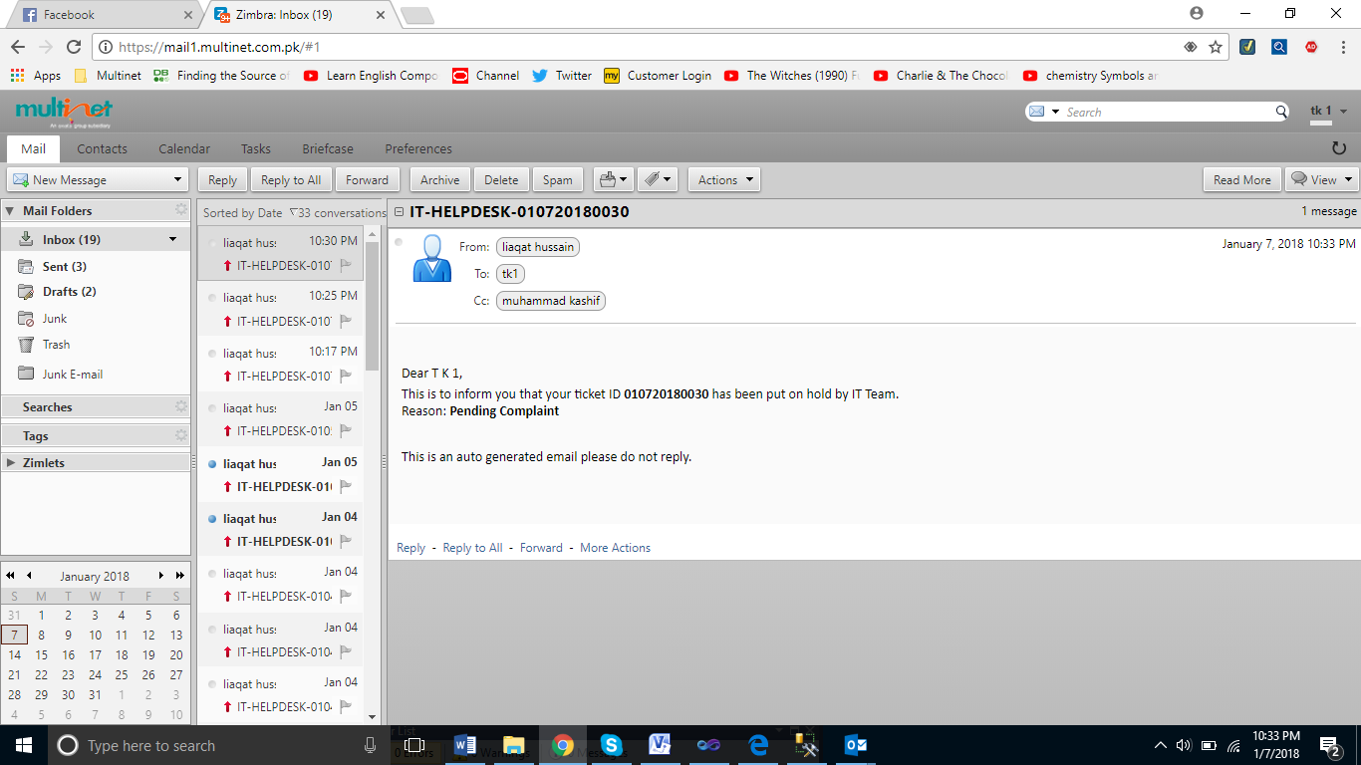

**Support Engineer Send Email in Case of Pending Complaint**

* Pending Complaint
* Email Flow: **Pending**

